Ministry Assistant:  Christy Pledge  Email: capledge@att.net  Cell Phone:  731-334-2120 | Dyer Baptist Association  Address: P.O. Box 296 Dyersburg 38025  Office Phone: 731-285-2727  Website: www.dyerbaptistassociation.com  Director of Missions: Dr. Dennis Jones  Email: dbadom@att.net  Cell Phone: 615-946-5495 | August  Newsletter  Issue #11
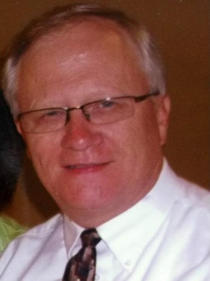
Notes Along The Journey,

Security Upgrades at the BCM - As I write this message, workers are finally able to install our new security cameras on the BCM Building. We are having about a dozen cameras installed both outside as well as inside. A new alarm system and keypad are also being installed for added security. Hopefully in the next week, their work will be done.

Upgrades in the Kitchen – The kitchen needs upgrades also. Most of our appliances need to be replaced so we have been working on this also. We have installed a new food warmer and industrial refrigerator. Soon we will install a new dishwasher and double oven stove. We want to thank all our churches who continue to give to the BCM Property and Equipment Fund. Your gifts have enabled us to pay for a little over half of these appliances. If you are considering giving a special gift to help us finish paying for these upgrades, please include your gift with your monthly DBA contribution.

2024 DBA Annual Meeting – Please put on your calendar October 21, the date of our Annual Meeting. This year Hillcrest Baptist Church will host our meeting. We begin at 3pm with a meal at about 5:30 and the second session at 6:30 pm. More details will come in next months’ Newsletter.

We Are Better Together – I recently received an article from the Mid-South Baptist Association in Memphis. The article talked about how we can do more by working together than by ourselves. Here is the link to the article. I trust it will encourage all of us to continue to cooperate with one another in the work of the Lord.
https://www.midsouthbaptist.com/we-are-better-together-july-newsletter/

Enjoying the Journey,
Dennis Jones, your DOM



Peace, I leave with you: my peace I give to you-not as the world gives, I give to you. Do not let your hearts be troubled, and do not be afraid.
John 14:27

Tennessee Collegiate Day of Prayer

30
TBMB Disaster Relief Training
TBMB 150 YRS. Celebration
B

Sunday, August 11th

As our Tn. BCMs promote this Day of Prayer, Tn. Baptists are encouraged to pray for campus ministers, college students, and university faculty.

July 30 Celebrating Our Stories, Memphis:
See the many shapes, colors and sizes that contribute to TBC.
August 13 Tennesseans on a Mission, Knoxville:
Feel the passion for sharing the gospel.
October 1 Together as One, Chattanooga:
Connect with the unity found in Christ.
November 9 TBC Loves Murfreesboro: *
Gather to minister and share the gospel.
(*in-person event, not online)
TBC 150th Anniversary - Tennessee Baptist Mission Board (tnbaptist.org)

Christmas Backpack Collections

TBMB Bible Reading

2024_BibleReadingPlan_NewTestament.pdf (tnbaptist.org)

October 21-23, 2024 at 9:00 AM-3:00 PM
West Jackson Baptist Church, 580 Oil Well Road, Jackson
Contact: Alan Teel 731-660-4535

TBMB Global Hunger Sunday

VBS Reporting
TBMB Summit and Pastors Conference

Sundy, August 25th
Tennessee is one of the hungriest states in the country. Many people in our communities do not have enough to eat or lack the financial resources to buy adequate food for their households. On this Global Hunger Sunday, as you give to the Global Hunger Relief offering through the Tennessee Baptist Mission Board, you are helping to provide food for hungry families in Tennessee, North America, and around the world.

TBMB Summit and Pastors Conference is November 10th- 12th at Embassy Suites, 1200 Conference Center Blvd, Murfreesboro, United States
This year, there will be no events held on Wednesday, November 13. The final Annual Meeting Session will happen the evening of Tuesday, November 12th. Also, for 2024, there will be no breakout sessions and childcare will not be available.
Summit: The Gathering of Tennessee Baptists - Tennessee Baptist Mission Board (tnbaptist.org)
Pastors Conference - Tennessee Baptist Mission Board (tnbaptist.org)

Treasurer's Report
October 2023-September 2024
Undesignated Receipts
 | June | YTD
Beach Grove | 150.00 | 1,400.00
Beech Grove Viar | 400.00 | 800.00
Bogota | 0.00 | 1,874.56
Calvary Chapel | 0.00 | 0.00
Church Grove | 200.00 | 1,600.00
Curve | 0.00 | 2,681.00
Dyersburg First | 2,500.00 | 22,500.00
Dyersburg Second | 130.00 | 1,170.00
Emmaus | 0.00 | 1,200.00
Enon | 106.97 | 1,083.17
Evansville | 34.04 | 400.37
Fairview | 0.00 | 0.00
Finley | 728.40 | 6,980.00
Fort Hudson | 0.00 | 600.00
Fowlkes | 50.00 | 450.00
Gates | 44.51 | 435.20
Halls | 0.00 | 3,014.89
Halls Westside | 225.00 | 1,665.00
Harmony | 120.50 | 1,244.89
Harvest | 0.00 | 1,561.26
Hillcrest | 1,647.87 | 15,942.53
Lenox | 0.00 | 0.00
Macedonia | 494.61 | 4,819.76
Mary's Chapel | 542.00 | 2,245.29
McCullough Chapel | 0.00 | 1,119.30
Miston | 0.00 | 0.00
Mt Tirzah | 99.78 | 963.42
Mt Vernon | 0.00 | 8,780.03
New Hope | 0.00 | 0.00
New Mitchell Grove | 0.00 | 400.00
Newbern FBC | 2,552.54 | 26,754.35
Parrish Chapel | 25.00 | 225.00
RoEllen | 211.72 | 2,386.00
Southside | 123.33 | 1,319.34
Springhill | 0.00 | 0.00
Three Oaks | 0.00 | 0.00
Trimble FBC | 350.00 | 2,800.00
Westside, Dyersburg | 0.00 | 0.00
Williams Chapel | 0.00 | 1,200.00
Woodville | 0.00 | 200.00
Zion Hill | 193.26 | 1,454.10
Church Donations | 10,929.53 | 121,269.4 6
TBMB Income | 3,542.67 | 32,040.03
Total | 14,472.20 | 138,837.29

Mark Your Calendar

August
1st-31st WMU Christmas in August
11th Tennessee Collegiate Day of Prayer
12th Pastors and Wives Breakfast
12th Women’s Ministry Meeting
25th TBMB Global Hunger Sunday
26th Pastors and Wives Breakfast

September
9th Pastors and Wives Breakfast
9th Women’s Ministry Meeting
10th Union Univ. West Tn. Pastors Banquet
23rd Pastors and Wives Breakfast
30th Annual Church Profile Packet Due

October
1st Pastor Appreciation Month
14th Pastors and Wives Breakfast
21st 99th Annual Meeting
28th Pastors and Wives Breakfast

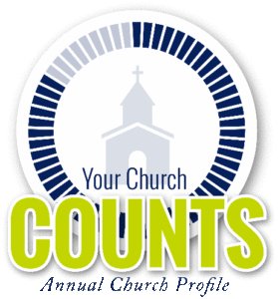
ACP Packet is Due September 30th, 2024
Please call the office at 731-285-2727 or Christy @ 731-334-2120.

Church News

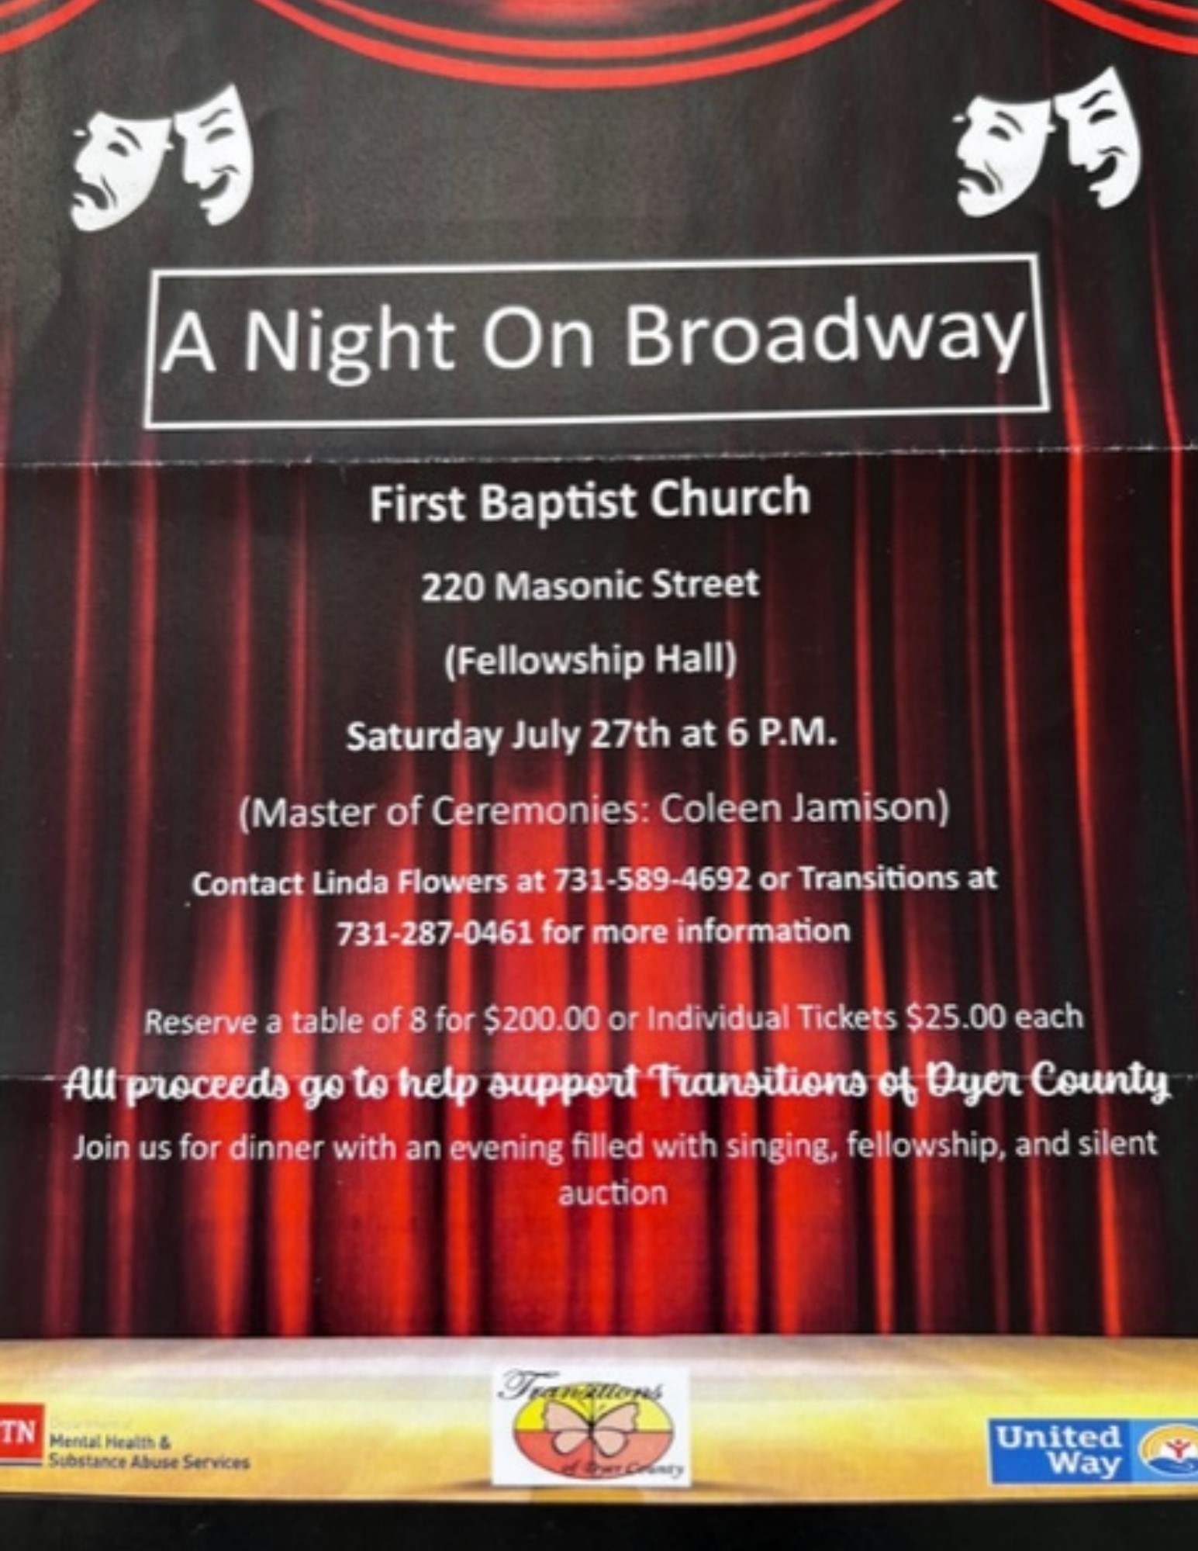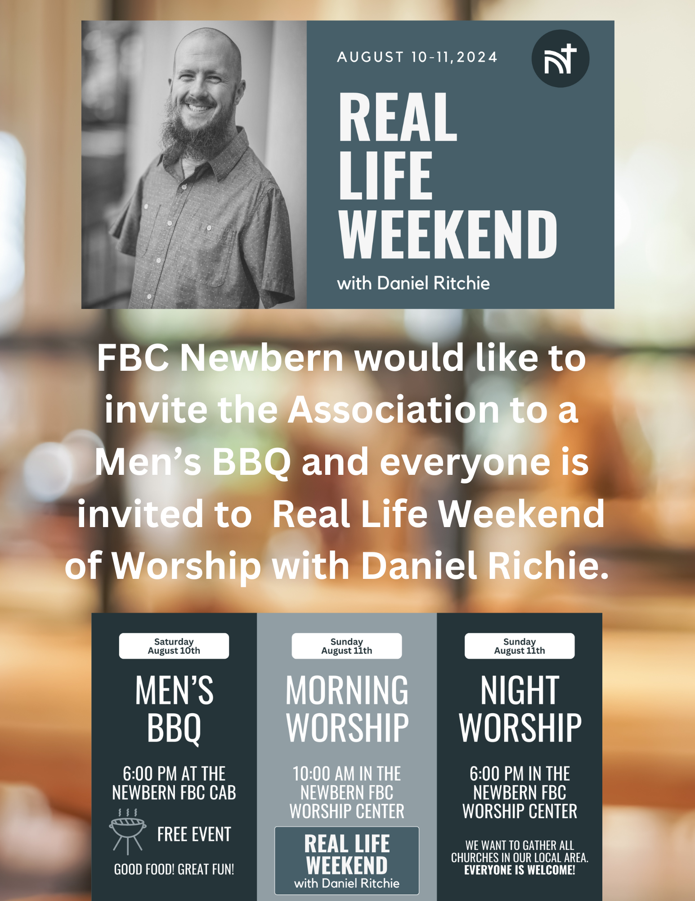
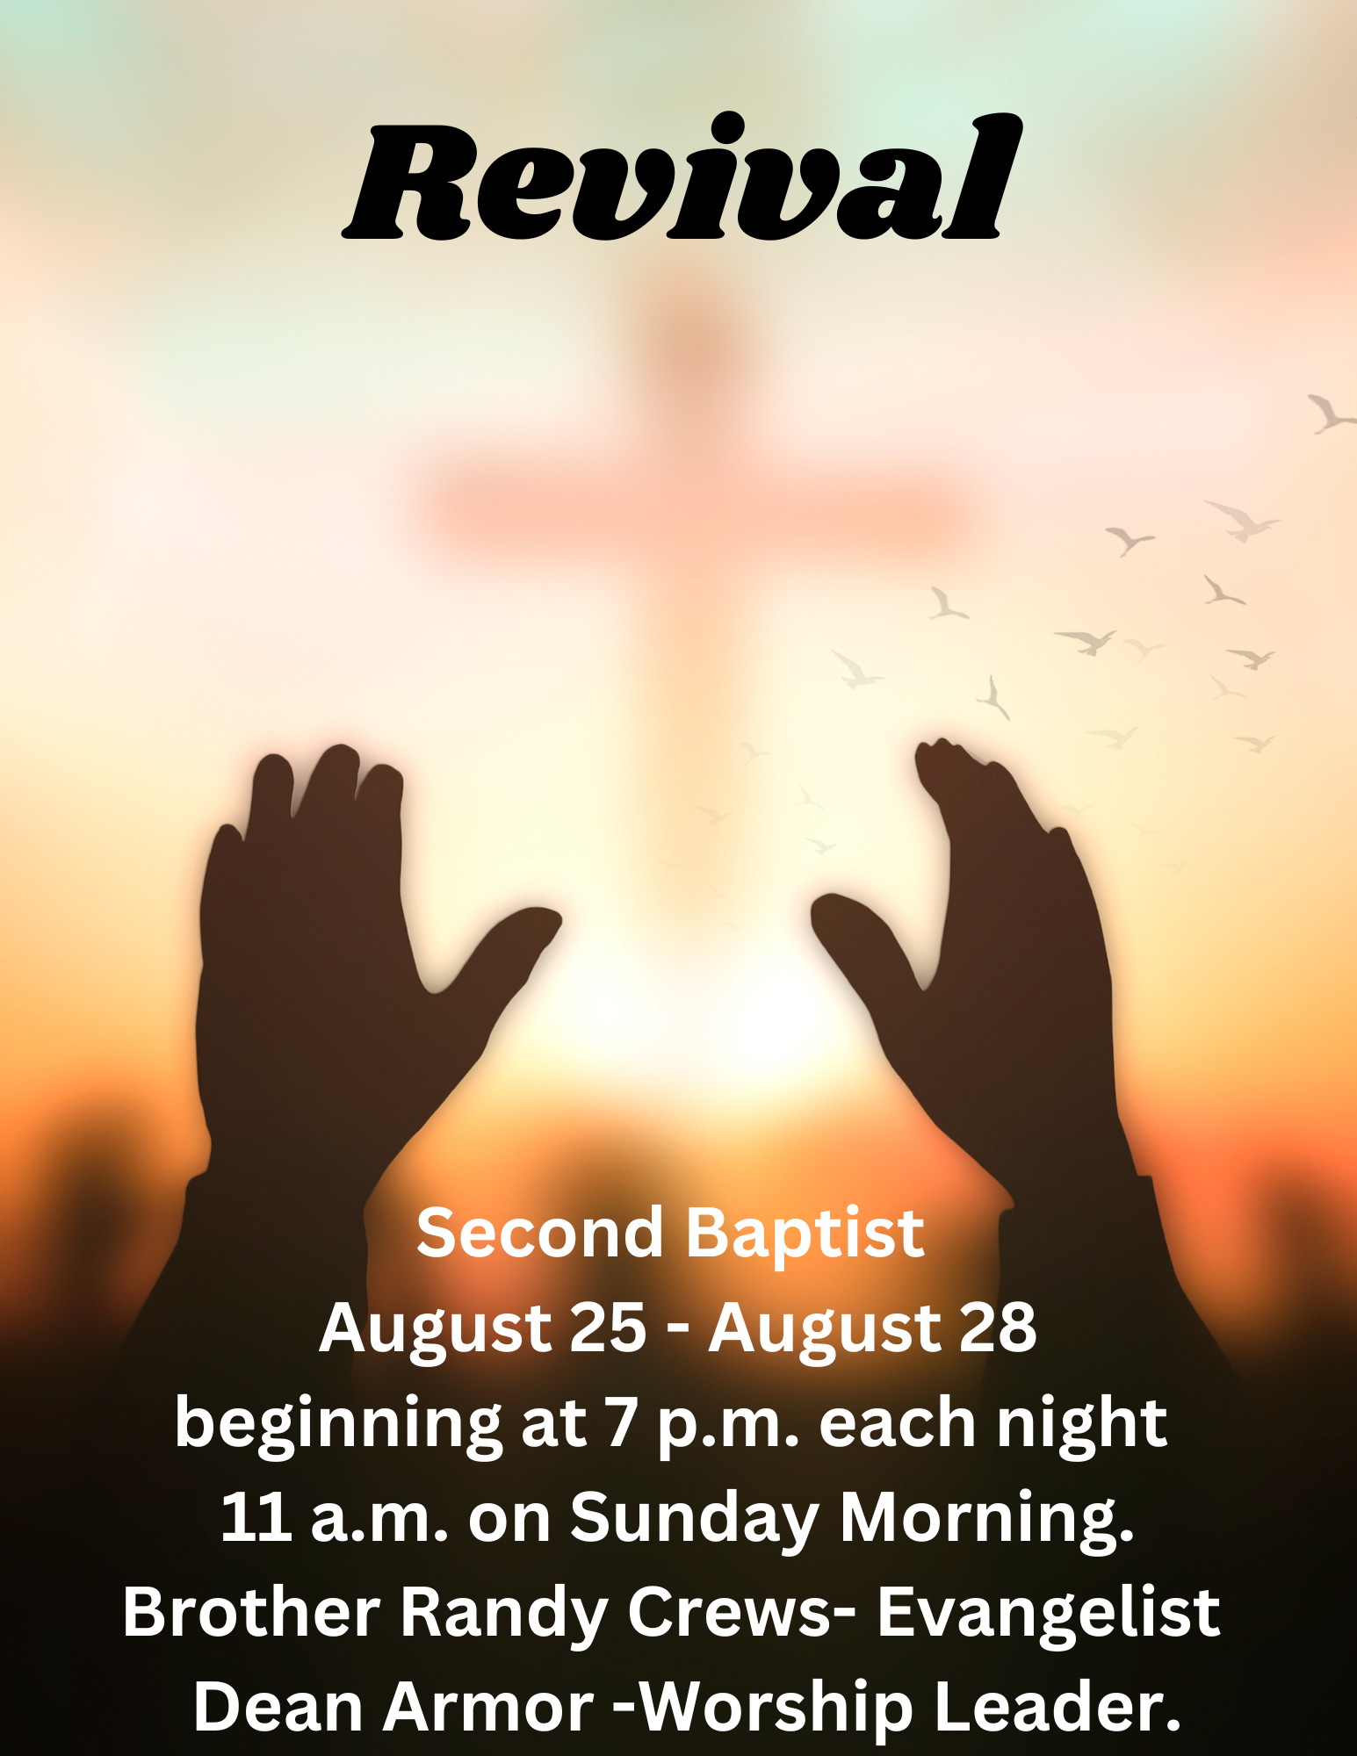

Women’s Ministry Meeting
The Women’s Ministry will be meeting at Timbers on Monday, August 12th @ 5:30pm.



Lord, our Lord,
How majestic is your name in all the earth?
Psalm 8:9

Messenger

The

Enon Baptist Church in
Halls, Tn.

New Mitchell Grove in
Halls, Tn.

Southside Baptist Church in
Dyersburg, Tn.

Hillcrest Baptist Church in
Dyersburg, Tn.

Macedonia Baptist Church in
Ripley, Tn.

Mount Vernon Baptist Church in
Halls, Tn.

Pastors and Wives
Birthdays

Churches Looking
for a Pastor

11th Mark LaRue- FBC Newbern

14th Nadine Naylor- Southside BC

16th Cecilia Koonce- Second BC

19th Kristie Willis- Mary’s Chapel BC

1st Eddie and Meline Willbanks
McCullough Chapel BC

11th Mark and Kimsey LaRue
FBC Newbern

17th Joe and Nadine Naylor
Second BC

23rd Randy and Melvine Crews
FBC Newbern



Churches Looking for
a Worship Minister



West Tennessee Pastors Appreciation Banquet
DBA Collecting Literature

Pastors and Wives
Breakfast

We are happy to announce that the Dyer Baptist Association is now collecting used literature. You can bring your used literature to the DBA Office Monday-Wednesdays 8:15-4:15. If you need it picked up please contact Mr. David Allen at 731-377-9695. If your church is in need of some of the old literature please contact us at the DBA Office 731-285-2727 or contact David Allen.





Our condoliances go out to the families of Gary Durham (Hilcrest), Joyce Criswel (Second Baptist, Dyersburg), Jerry Dunavent (Kay Dunavents Father), and Ottis Kissel (New Mitchell Grove, Halls)
Please keep these families in your prayers.

